Firenze October 24 - 27, 2023

Advanced Training Workshop
4-day full immersion in Periodontal Regeneration

Pierpaolo Cortellini

Day 1 – Tuesday October 24 - 9:00 – 18:00: Biologic & clinical background
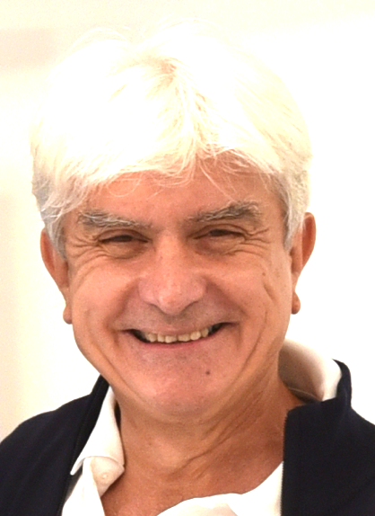
- Clinical objectives, indications, limits and prognosis of regeneration
- Regeneration in the global treatment planning:
timing and interactions
- Preparation of the patient: cause – related therapy and
soft tissue preservation
- Assessment and management of patient and defect factors
to increase predictability
- Diagnosis and control of endodontic conditions, tooth mobility
and local contamination of the defect
- Pre-surgical diagnosis: generating a 3-D clinical and radiological assessment of intrabony defect morphology
- Critical evaluation of periodontal regenerative materials

Day 2 – Wednesday October 25 - 9:00 – 18:00: Infrabony defects
- Soft issue handling, defect debridement and suturing techniques
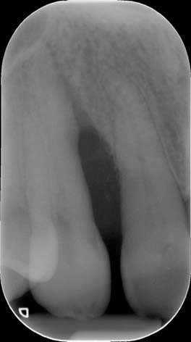
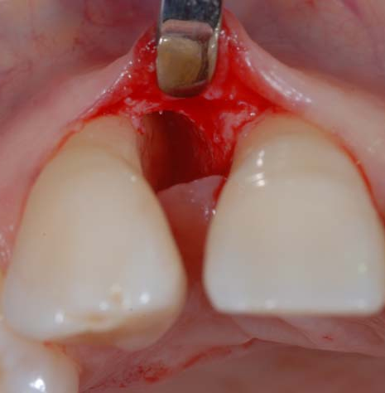
- Flap design
a. papilla preservation flaps
b. Microsurgery and minimally invasive surgery
c. Flap design for multiple defects
- Biologically driven regeneration: the regenerative strategy
- 3-D video presentations
- Post-surgical management and control of complications
- Presentation and discussion of clinical flow-charts
- Long-term clinical outcomes

Day 3 – Thursday October 26 - 9:00 – 18:00: Furcation defects
- Multi-rooted teeth: anatomy, diagnosis and prognosis of furcation defects
- Clinical objectives, indications, limits and prognosis of regeneration in furcations
- Critical evaluation of periodontal regenerative materials
- Debridement of the furcation. Choice of Instruments and materials
- Class II furcation in lower molars and buccal class II furcation in upper molars: the buccal / lingual flap and the coronally advanced flap
- Mesial / distal class II furcation at upper molars associated to intrabony defects: the papilla preservation flap and the minimally invasive surgery
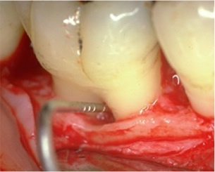
- Class III furcation at lower molars: an extreme challenge
- 3-D video presentations
- Post-surgical management and control of complications
- Presentation and discussion of clinical flow-charts
- Long-term outcomes
Day 4 – Friday October 27 - 9:00 – 16:00:
Hands-on surgical exercises on anatomical simulators

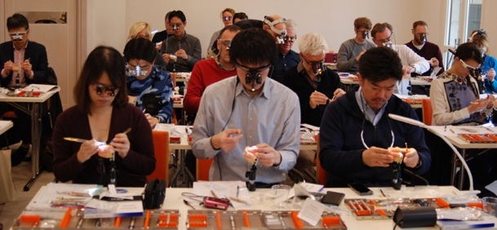
- Hands-on in-depth tutorial on surgical methods
a. Surgical instruments and materials
b. Papilla preservation flaps
c. Minimally invasive surgical techniques
d. Single and multilayer internal mattress sutures
e. Application of regenerative materials.
- Discussion of surgical tips.

Participants should bring with them magnifying loops with independent light

End of the course and Certificate Celebration
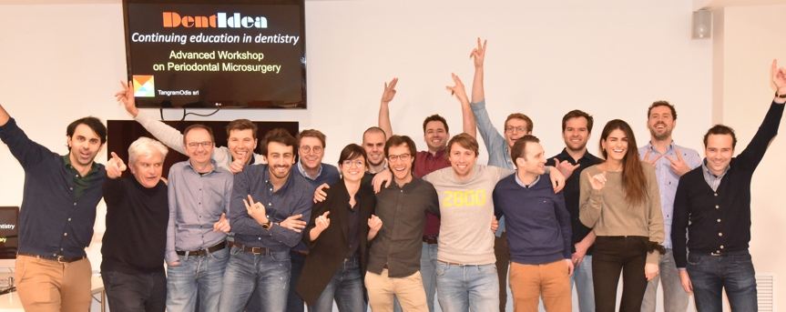

Venue of the course:

Cortellini Training Centre
Via C Botta 18 - Firenze

Suggested Hotels
(You are invited to make your hotel reservation as soon as possible)

Hotel Grifone***, Via G Pilati, 20-22.
Phone +39 055 623300, www.hotelgrifonefirenze.com
(offers preferential rates for the course participants)

Residence Forte 16***, Viale Gramsci 16
Phone +39 055/5321990, info@forte16.com, http://www.forte16.com

B&B Hotel Firenze City Center***, Viale G. Amendola 34
Phone +39 055 2343201, fi.center@hotelbb.com

Grand Hotel Mediterraneo****, Lungarno del Tempio 44
Phone +39 055 660241, info@hotelmediterraneo.com

